 **Hassell Primary Update 17.6.2022**

Dear Parents and Carers,

It’s been another busy week and definitiely a hot one! Thank you for ensuring your children came to school wearing suncream, sun hats and had their water bottles as they were definitely needed. Please can all children ensure they continue to do the same while the lovely weather continues.

**Thank you Mscape!**

This week we had a visit from Mscape Escape rooms to challenge our Year 5 and 6 children. They set up the classroom with lots of clues and puzzles and the children became adventurers for the morning. They completed a range of group puzzles against the other teams in their class before the final challenge of a whole class puzzle. The children had a brilliant morning and thoroughly enjoyed the activities. Thank you Mscape for providing a very entertaining and different type of problem solving!

If you would like to know more about the escape rooms, which are run by one of our families at Hassell, please visit [www.mscapeuk.com](http://www.mscapeuk.com)

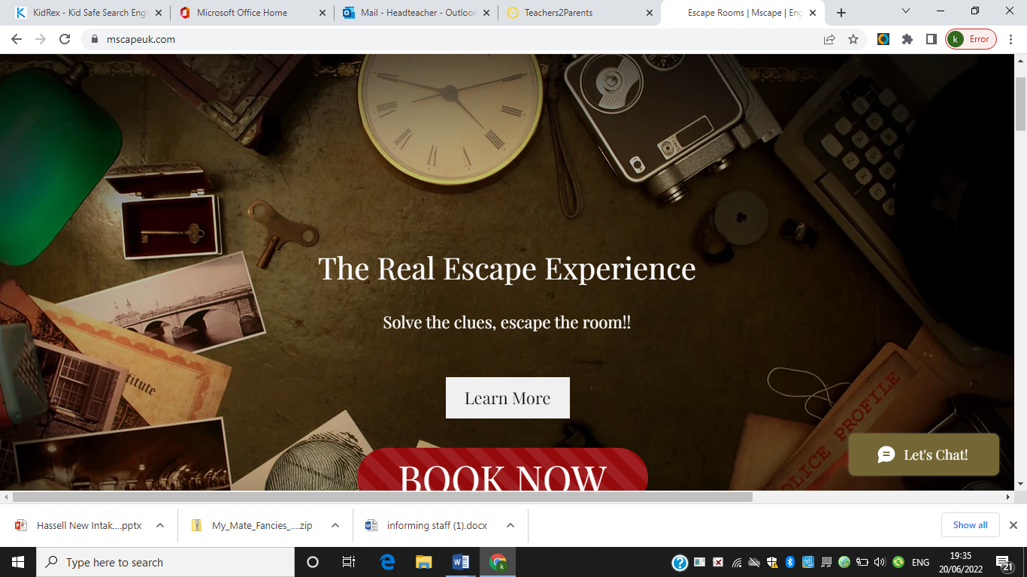

**Art collaboration**

Denise O’Sullivan has been working on a military button project with each class. This is in conjunction with the Barracks Trust. We’ve had lots of fun and look forward to seeing the finished products.

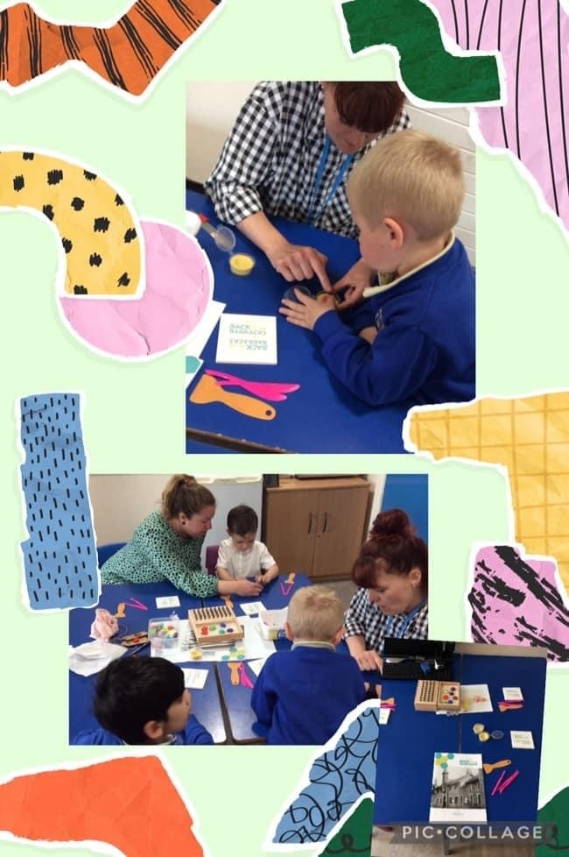

**Gruff Farm Visit**

This week our Reception class had a visit to Gruff farm and a thoroughly enjoyable day. Thank you to the mums and dads who came to help; the children had a really great time learning about the animals and making arts and crafts. Thank you to everyone who supported this trip.

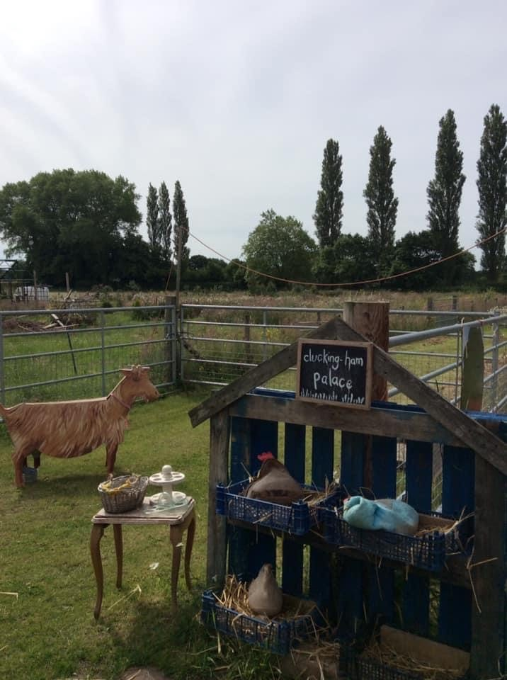

**Staff Changes:**

**Goodbye**

As you will be aware, with reducing pupil numbers, we now have 1 class in Reception each September, rather than 1 and a half. As a result of this, very sadly, we have had to make reductions to the numbers of teachers in school. As part of this process, Mrs Goodstadt and Miss Dale have both requested voluntary redundancy which has been accepted by the Governing board. This means that they will be finishing school at the end of August. Both staff will be greatly missed next academic year, but we wish them well in their new adventures and hope they enjoy their last few weeks at Hassell.

**Good Luck**

Mrs Hill has completed her last week as she finished for her maternity leave. We had a short celebration assembly to give her some goodies from the staff and children and wish her good luck for her baby’s imminent arrival. Mrs Hill is due in the last week of school and we hope to have great news to celebrate before we finish for the summer holidays.

**Diary Dates: These will be updated as the term progresses**

**June:**

Week beginning 20th – Y4 multiplication check

Tuesday 21st -KS2 woodwind assembly

Tuesday 21st – Y1,3,4 time for sport lesson

Wednesday 22nd – KS1 RNLI workshops

Thursday 23rd – Y5 drama workshop

Friday 24th – Nursery and Reception transition visit one 9.15-10.15

Monday 27th Loudmouth productions – Y5/6

Tuesday 28th –Y5/6 to Knowsley Safari Park

Tuesday 28th – Y1,3,4 Time for Sport lesson

Wednesday 29th – Rock Steady alternative date (instead of Tuesday)

Thursday 30th – Y5 drama workshop

**July**

Friday 1st – EYFS Transition visit 2 9.15-10.15

Monday 4th – Y5 at Orme Academy all day and evening performance

Tuesday 5th – Clayton Y6 transition day

Tuesday 5th – Y1,3,4 Time for Sport lesson

Tuesday 5th – Rock Steady concert for parents

Wednesday 6th – EYFS sports morning at school. 9.15 start

Wednesday 6th – Y6 transition day – Clayton, Thistley Hough, Chesterton, Newcastle Academy

Thursday 7th – KS1 Sports morning at NULS 9.30 start

Thursday 7th – Anchor Creative Education visit (English )

Thursday 7th – end of year reports out

Friday 8th – EYFS transition day 3 9.15-10.15

Friday 8th – Summer Fair 3.15-5.30

Tuesday 12th – Y1,3,4 Time for sport lesson

Tuesday 12th – drama club presentation for parents 3.30pm

Wednesday 13th – Y6 tubing visit

Thursday 14th – Y6 Leaver’s Assembly 6.30 start

Friday 15th – Y6 leaver’s disco 6.30 – 8pm

Tuesday 19th – Last day of term for children

Wednesday 20th – INSET day for staff

If you have any questions or things you would like to discuss with staff, please feel free to talk to myself or the staff on duty in the mornings or give the office a ring and leave your child’s class teacher a message and they will get back to you as soon as possible. We are also available via the office email on [office@hassell.staffs.sch.uk](mailto:office@hassell.staffs.sch.uk)

Kind Regards

Kirsty Broome

Head Teacher