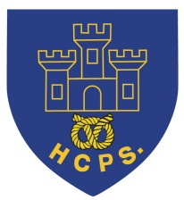 **Hassell Primary Update 27.5.2022**

Dear Parents and Carers,

**SATS, phonics and times tables checks**

Well done to Year 2 children who have completed their SATs test over the last 2 weeks. They have worked incredibly hard and we are very proud of them all. Results will be available in the children’s summer reports.

During the week beginning the 7th June, we have the phonics screening checks for Year 1 based around the work that the children have been doing n their phonics lessons. Please keep practising your child’s phonics homework with them to support their reading.

Year 4 children also have their times tables checks. These will be completed online and work exactly the same way as the sound check on TT Rockstars. Please can all Year 4 children keep practising at home on the sound check to ensure they are confident to take their timed test on their multiplication tables. The check covers all times tables up to 12x12.

**Jubilee Day**

The children made a real effort for our Jubilee day on Thursday and looked amazing in their outfits. We celebrated together in the afternoon with a party on the playground followed by ‘afternoon tea’ in the classroom. A huge thank you to Mrs Maydew and Mrs Byatt from the PTFA for putting up all the decorations and providing everyone with their party food. We really appreciate all you did and the children really enjoyed their afternoon treat.

Here are some photos from the afternoon:

  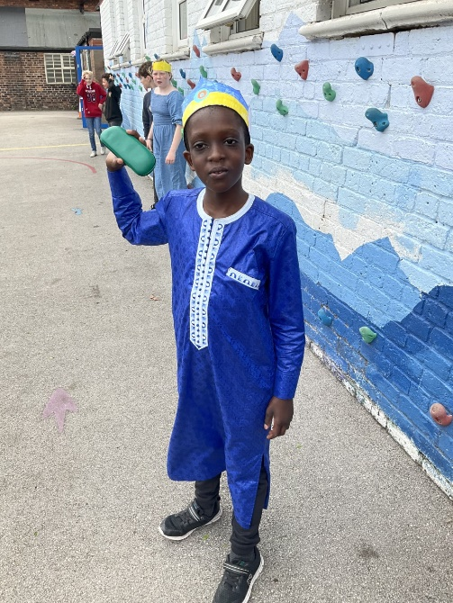

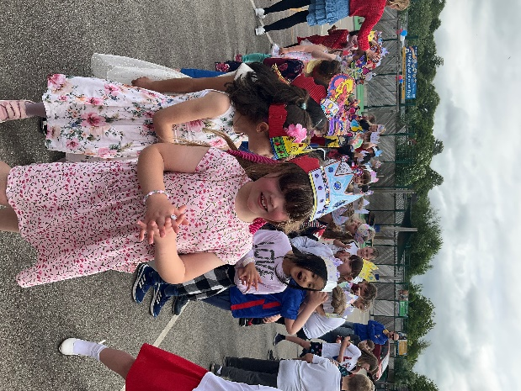 

 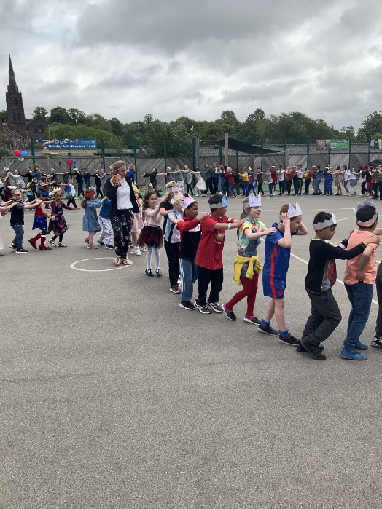 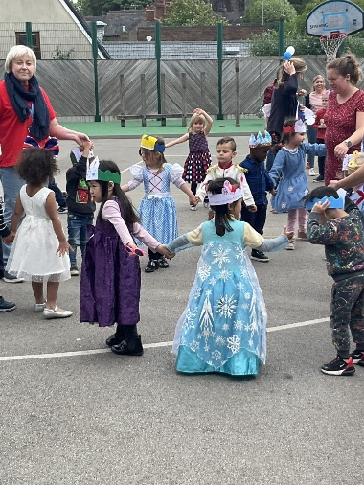

**Sports day**

Well done to everyone who took part in the KS2 sports day today. Thank you to LMA for doing a great job organising and for all the adults who came to watch. The team results were:

Wedgewood – 99points

Bridgewater – 107 points

Matthews – 111 points

Spitfires – 123 points

Well done to the Spitfires who were our overall winners.

Thank you also to our team captains and helpers in Y6 who did a great job giving out places and stickers on the finish line.

 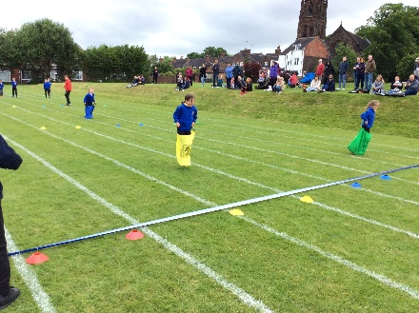 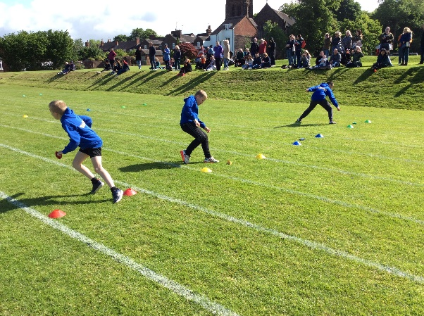 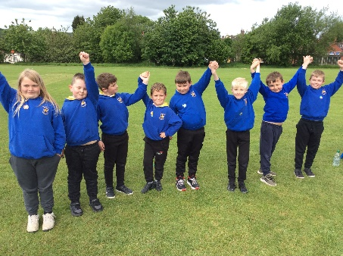 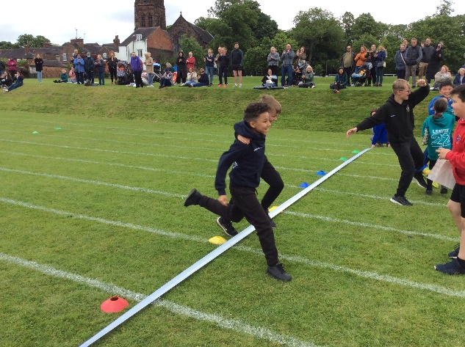 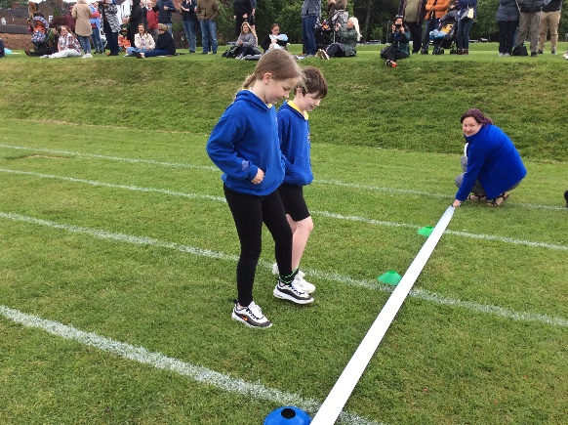

**Young Voices Manchester**

Well done to the Y5 and Y6 children who went to Young voices in Manchester on Wednesday. They had a great day and sang their hearts out in the concert. Mrs Pezzaioli has made a great video clip of the day which can be watched on our Hassell Primary School face book page. It was an amazing experience for the children to be part of such a large performance in a huge arena and we are really proud of them all for being such great ambassadors for our school.

**Goodbye**

Today we said goodbye to Mrs Dreher as she leaves us to start her new job at Stafford college working with older students. We are sad to see her go but wish her lots of luck and know she will do a fabulous job!



**Inset Day**

Just a reminder that the children return to school on Tuesday 7th June as Monday 6th is an INSET day for staff.

**Diary Dates: These will be updated as the term progresses**

**May:**

Monday 30th May – Friday 3rd June – HALF TERM

**June:**

**Monday 6th June – INSET day. School closed to pupils**

Tuesday 7th June – School open to pupils

Week Beginning Tuesday 7th – Phonics screening week

Wednesday 6th – 24th – Year 4 multiplication check to be completed during this period

Thursday 9th  - Year 5 drama workshop

Thursday 9th – Y3/4 chance to shine cricket

**July**

Wednesday 6th – EYFS sports morning at school. 9.15 start

Thursday 7th – KS1 Sports morning at NULS 9.30 start

Thursday 14th – Y6 Leaver’s Assembly 6.30 start

Friday 15th – Y6 leaver’s disco 6.30 – 8pm

If you have any questions or things you would like to discuss with staff, please feel free to talk to myself or the staff on duty in the mornings or give the office a ring and leave your child’s class teacher a message and they will get back to you as soon as possible. We are also available via the office email on [office@hassell.staffs.sch.uk](mailto:office@hassell.staffs.sch.uk)

Kind Regards

Kirsty Broome

Head Teacher