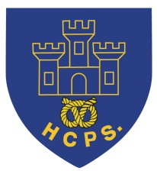 **Hassell Primary Weekly Update 4.2.2022**

Dear Parents and Carers,

**Covid update**

I’m delighted to say that we don’t have any new positive cases in school at the current time. There are a small number of pupils who are coming to the end of their isolation period sand we look forward to having them back in school next week. Thank you for your continued support in daily LF testing where there have been cases within year groups as this has helped to maintain early identification.

**NSPCC NUMBER DAY**

Today we have been taking part in the NSPCC Number day. Thank you to all the children who have taken part. As well as clothing items with numbers we have some amazing costumes that the children have created. Funds raised today will be going to the NSPCC to support their work with vulnerable children. If you would like to know more about how our fundraising helps please visit: <https://www.nspcc.org.uk/support-us/events-fundraising/social-special-events/number-day/>

**Music Lessons**

This week we had a visit from Dan who showed the children different aspects of playing the drums. We really enjoyed his visit, although it was very loud!

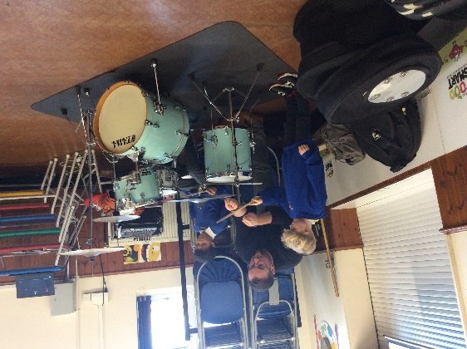 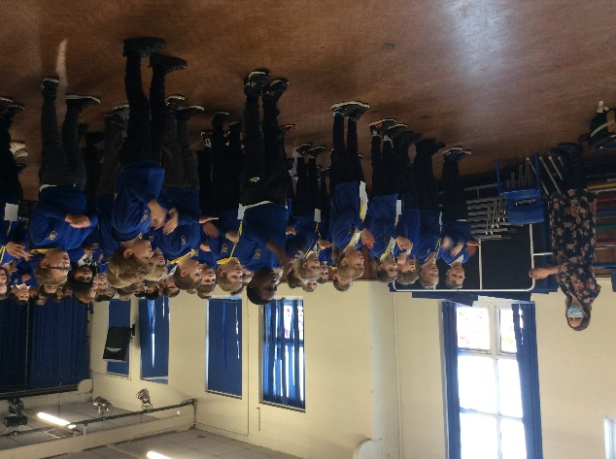

Thank you to everyone who completed music lesson requests. We have managed to accommodate lessons for a range of different instruments and Mrs Pezzaioli will be in touch soon with further details for those involved.

**Celebration Assemblies**

Well done to Jack, Logan and Tristan for their input to the celebration assemblies. Jack has made an amazing Hogwarts Castle construction and Logan and Tristan cooked a full Italian meal, coplete with appropriate table settings. Well done boys! Don’t forget to send in anything that you would like to celebrate with us from home ready for our assembly.

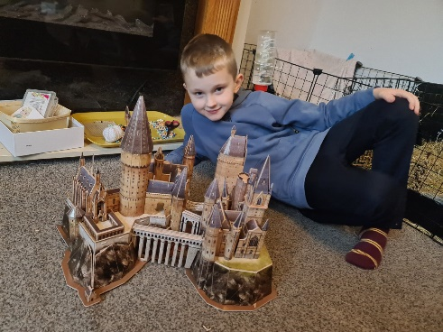 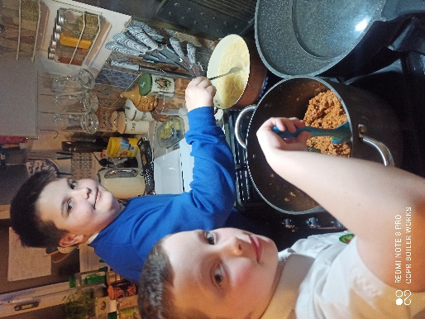

**Children’s Mental Health Week**

Children’s Mental Health Week is taking place from 7th – 13th February 2022 and is an opportunity to shine a spotlight on and raise awareness for children and young people’s mental health.

On Friday 10th February we will be having a ‘Dress to Express’ day and we will be encouraging all children and staff to use clothing and colour to express themselves. Your child/children’s Dress to Express outfit can be as simple or elaborate as they like! They could wear their favourite clothes, colours, dressing-up costume, sports clothes- anything that makes them happy and comfortable! We would be very grateful of a donation of £1 on the day. The funds raised will be shared between the Place2B Charity and school to support the Eco-Council with the Growing Together theme and providing funds towards buying class planters and plants for the front of school.

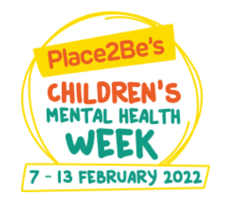**Children’s Mental Health Week 2022 - Growing Together**

**Culture Week**

The school’s culture week this year will be on the week beginning 14th February and will focus on North America.

The children will undertake a range of activities to help them learn about the culture, including dance routines, stories, art etc.

If you have some knowledge of this area and would be willing to share your expertise with the children, please contact Mr Murdoch at [a.murdoch@hassell.staffs.sch.uk](mailto:a.murdoch@hassell.staffs.sch.uk) or speak to your child’s teacher. This could be to teach the children some words from a new language, to share some food or to simply tell the children what the country and its people are like.

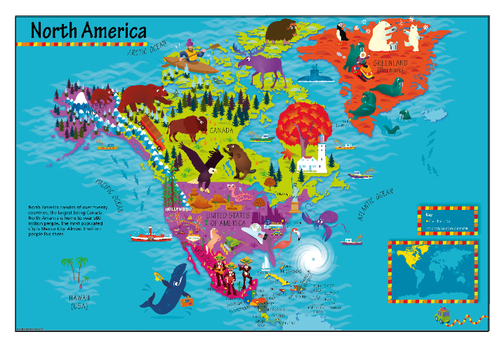

**Care Club**

As you may be aware, our care club runs before school, after school and during the holidays. We currently have spaces before and after half term. If you would like to have a place, please contact Miss Barlow at [happytimesltd@outlook.com](mailto:happytimesltd@outlook.com) or contact school for further details.

**Diary Dates: These will be updated as the term progresses**

**February:**

Week beginning 7th Feb – children’s mental health week.

Tuesday 8th Feb – safer internet day

Friday 11th Feb – Own clothes day £1 donation (see above)

Week beginning 14th Feb – Culture week. Theme is North America

21st Feb to 25th Feb – Half Term

Monday 28th Feb – INSET DAY. School closed to pupils

Tuesday 1st March – children return to school

Tuesday 8th March – Dental Survey for R and Y1 children

Week beginning 11th March – Science week.

If you have any questions or things you would like to discuss with staff, please feel free to talk to myself or the staff on duty in the mornings or give the office a ring and leave your child’s class teacher a message and they will get back to you as soon as possible. We are also available via the office email on [office@hassell.staffs.sch.uk](mailto:office@hassell.staffs.sch.uk)

Kind Regards

Kirsty Broome

Head Teacher