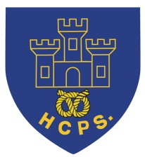 **Hassell Primary Weekly Update 22.10.2021**

Dear Parents and Carers,

**Covid Update**

As you are aware, we have had several positive cases reported within the last 2 weeks. I hope that those individuals who have contracted the virus are safe and well and we wish them a speedy recovery. I would also like to take this opportunity to thank all the parents and carers who have supported us by taking their children for PCR tests and doing regular lateral flow tests. This has helped us enormously as the range of positive case symptoms have varied from mild tummy ache, to tight chests and high temperatures and coughs.

After half term, all being well, we will return to the ‘normal structure’ of EYFS, KS1 and KS2 and will go back to shared break times at KS2. All of the existing measures such as additional cleaning, hand sanitiser availability etc will continue. Please continue to notify school if your child tests positive over the holidays so that we can make any adjustments as required.

**Halloween Day**

Thank you to the PTFA for decorating the outside of school and for providing a sweet treat for the children – they were very well received. The children all had fun in their classes for their party afternoons in replacement of the disco. I was incredibly impressed with the variety of costumes that the children came dressed in, thank you to all our families for their efforts. Here is a snapshot of the different classes.

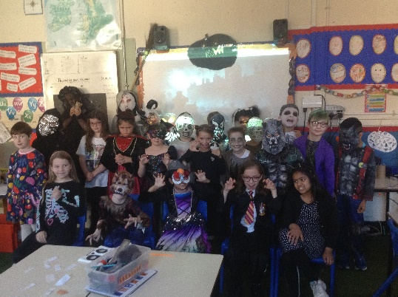 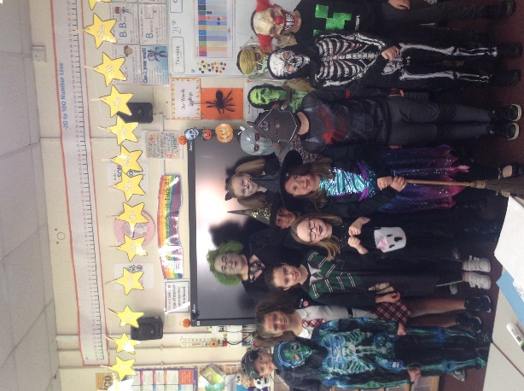

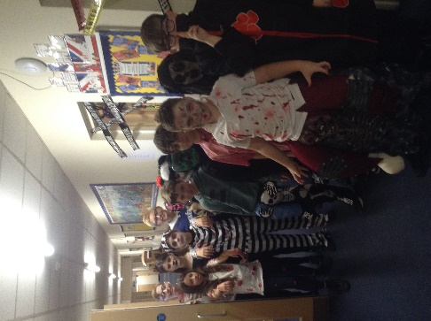 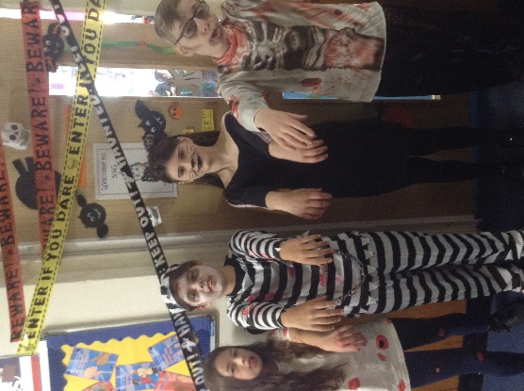 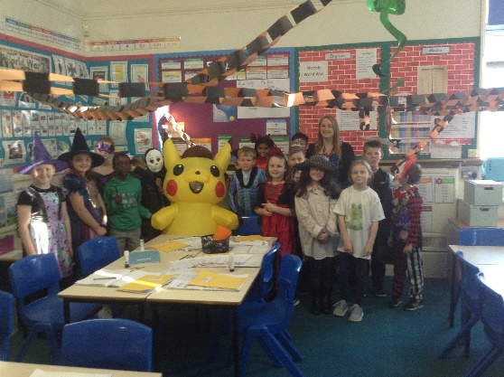

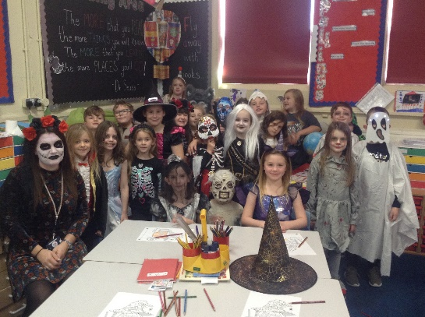 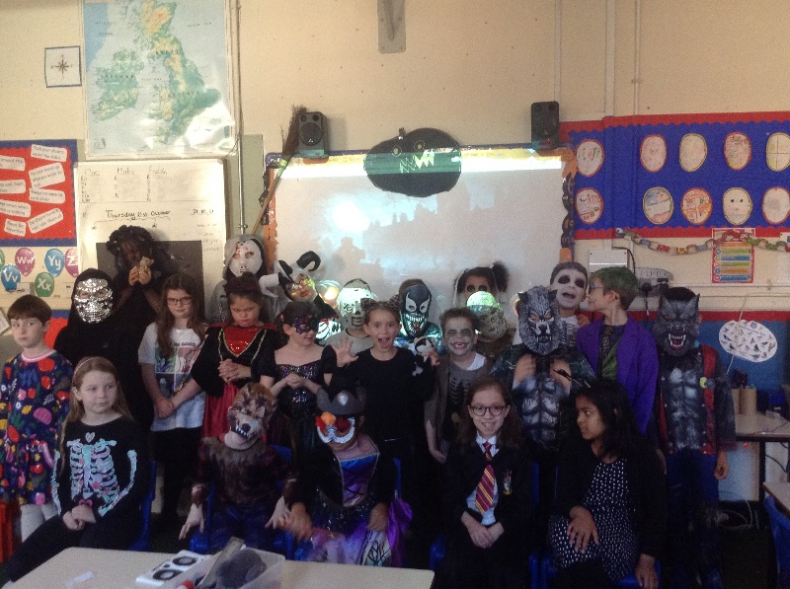

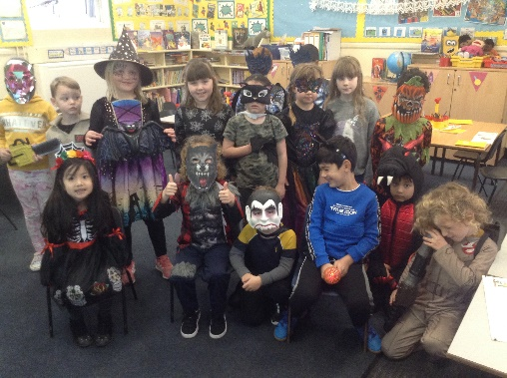 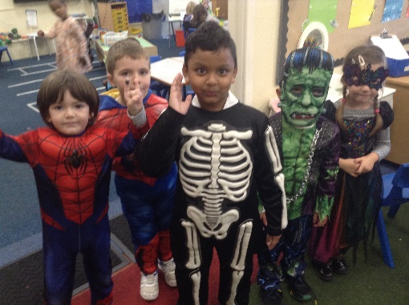

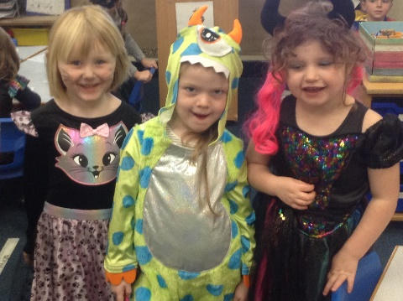 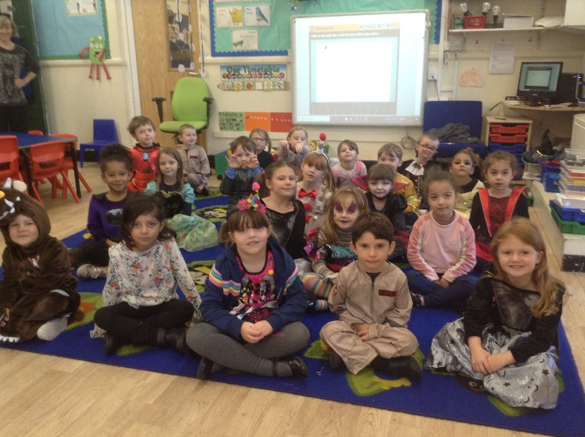

**Show Racism the Red Card**

Today we have had a themed day in school to raise awareness about racism. The theme is ‘show racism the red card’ and is linked to the campaign to eliminate racism, particularly in sporting settings. The children have come into school dressed in their own clothes, ideally with a red coloured theme. To learn more, please click on the following link:

<https://www.theredcard.org/>





We will be having an open morning on Saturday 13th October from 10am – 12.00. If you have children due to start in nursery or reception in 2022, or would simply like to come and have a look at our school and all that we have to offer, please contact the office after half term to book an appointment slot. Please spread the word to friends and family if they would like to visit.

**Diary Dates:**

Until October 24th – collect Morrisons ‘It’s Good to Grow ‘ vouchers

Half Term – Monday 25th – Friday 29th October

**MONDAY 1st November - INSET DAY - SCHOOL CLOSED TO PUPILS**

Tuesday 2nd November – All pupils return to school.

Tuesday 9th November – Miss Dale’s parent’s evening. Please log in via your child’s google class account and book appointment slots via their calendar.

Saturday 13th November – open morning 10 - 12

If you have any questions or things you would like to discuss with staff, please feel free to talk to myself or the staff on duty in the mornings or give the office a ring and leave your child’s class teacher a message and they will get back to you as soon as possible. We are also available via the office email on [office@hassell.staffs.sch.uk](mailto:office@hassell.staffs.sch.uk)

Kind Regards

Kirsty Broome

Head Teacher