 **Hassell Primary Weekly Update 19.11.2021**

Dear Parents and Carers,

**Anti Bullying – Odd Socks Day**

Thank you to everyone who took part in Monday’s anti bullying campaign by wearing odd socks. Miss Dale lead the morning assembly and introduced the children to this year’s theme ‘one kind word’ along with Andy and the odd socks. If you would like to learn more, please click on the following link:

<https://andyandtheoddsocks.com/>



This week the children have learnt more about what it means to have bullying behaviour – how to spot it and, most importantly, how to STOP it. I would like to say well done to all the children for their positive attitudes and support of one another to help prevent bullying in our school. Miss Dale has also been round to classes today to spread a little happiness!

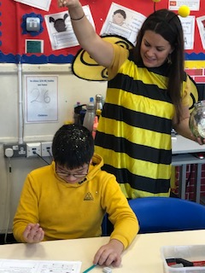

**TT Rockstars Day**

On Friday 26th November we will be having a maths day celebrating times tables and number work. The children will be able to come in dressed as their TT Rockstars avatar, or rockstar of their choice. The children have asked whether this can also include hair dye and make up – the answer is yes! Mrs Pezzaioli is busy making activities and resources for everyone and we can’t wait to see the children in their rock star creations. Please see below for some ideas of outfits

 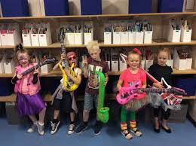 

**Be Bright Be Seen**

Just a reminder of our poster competition: Staffordshire CC have kindly donated some reflective prizes that the children can win by entering our school ‘Be Bright Be Seen’ poster competition. Posters should be A4 size and can be coloured in any medium. They should include the message ‘Be Bright Be Seen’. Posters should be returned to your child’s class teacher by Friday November 26th. Please remember to include your child’s name on the back.

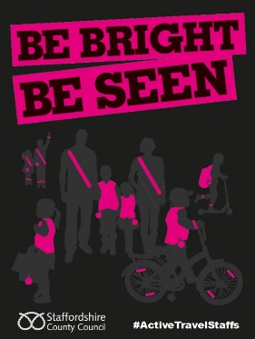 Winners will be announced on Thursday 2nd December.

**Children in Need**

Today is Children in Need day. Thank you to all the families who have taken part by wearing own clothes and giving a £1 donation. We raised £210 from school which is amazing and we also had a donation of £85 from a member of the public who had been saving his change. Thank you for your generosity!

**Cold Weather**

As we now have colder temperatures and wet weather creeping in, please can I remind all children to bring coats on a daily basis. Please ensure that your child’s coat has their name in so that it can be returned to the correct person if left outside.



**Panto**

The children in Early Years and KS1 will be having a visit from the pantomime later this term. Letters have been sent out this week with all the information required. Please can parents pay for their child’s ticket via parent pay.

**Keele Christmas Tree Farm**

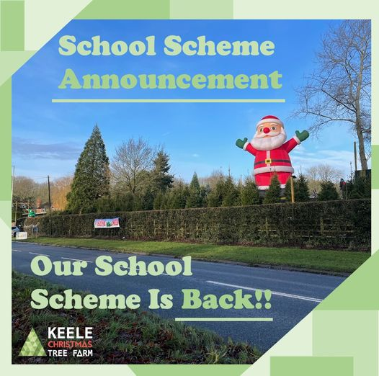

Keele Christmas Tree Farm have an offer for schools. When buying a tree from the farm, please mention Hassell Primary School and they will record the sale for our school. At the end of the season they will give school a % donation of all sales back. Don’t forget to mention us if you buy a real tree this year.

**Christmas Dinner**

Christmas dinner will be available to pre order this year via microsoft forms. Please see the menu for the choices available.

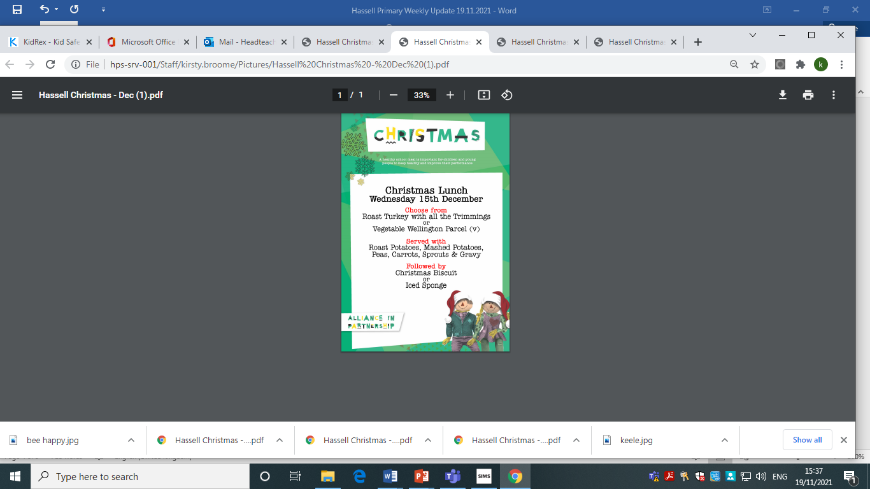

**Diary Dates:**

**November**

Tuesday 23rd – Entrust music visit with Year 5/6

Friday 26th - TT Rockstars Day – see above for rock star outfit ideas

**December**

Friday 3rd – Elf / Christmas Jumper Day (details to follow)

Tuesday 7th – Class 1D parent craft afternoon (details to follow)

Wednesday 8th – Class 2 B parent craft afternoon (details to follow)

Thursday 9th – KS1 and EYFS Panto - in school – please see letter 15.11.21

Monday 13th – last week of school. Class parties this week

Tuesday 14th – Rock Steady concert for parents (2.15pm)

Wednesday 15th – Christmas dinner day

Thursday 16th – Virtual Festival of Christmas for Y5/6

Friday 17th December – Last day of term. Own clothes day for fun (no donation)

If you have any questions or things you would like to discuss with staff, please feel free to talk to myself or the staff on duty in the mornings or give the office a ring and leave your child’s class teacher a message and they will get back to you as soon as possible. We are also available via the office email on [office@hassell.staffs.sch.uk](mailto:office@hassell.staffs.sch.uk)

Kind Regards

Kirsty Broome

Head Teacher