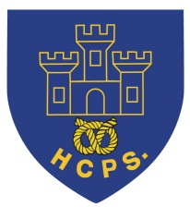 **Hassell Primary Weekly Update 18.3.2022**

Dear Parents and Carers,

It has been a busy couple of weeks with lots going on in school. Thank you to everyone who helped us support Comic relief with our own clothes day. The money raised will be sent to Comic relief and the charities they work with. This includes helping people who are struggling with poverty, those experiencing mental health issues and working with charities who support those with disabilities.

If you would like to learn more, please visit the comic relief website on:

<https://www.comicrelief.com/>

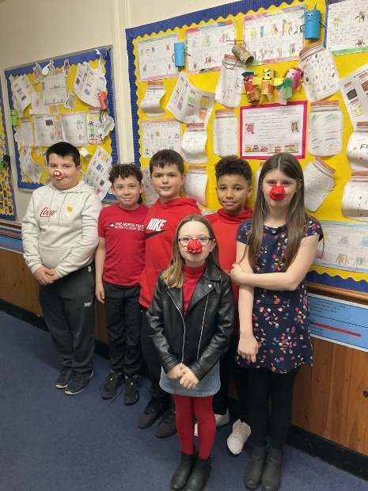

**MP Visit with the Eco Council and Student Council**

Today, we have had a visit from Aaron Bell, MP for Newcastle. He met with children from our Student council and Eco council to discuss the concerns and issues which are worrying them. These included questions about recycling, pollution, Walley’s quarry, concerns about safety within Newcastle, having more safe cycle and scooter routes within our town, amongst many others. The children were very polite and considerate and represented our school extremely well. Thank you to Mrs Brown and Mr Murdoch for coordinating this visit for us.

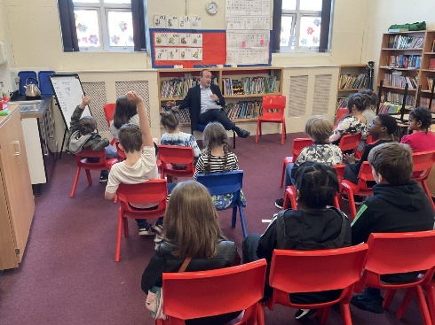

**Hassell’s Got Talent**

This year we will be holding our Hassell’s Got Talent competition for the children in KS2, years 3-6. Each class will be holding auditions during the week of the 28th March to select the finalists from their class. The finals will then be held during the last week of term.

The children can audition with anything that they would like to show, which may include singing, dancing, playing a musical instrument, comedy, magic … their choice is endless. All we ask is that the children choose activities which are able to be completed on the stage in the hall and do not put their safety at risk.

Any children who wish to audition for their class will need to practice their acts at home. Unfortunately, we will not be able to provide class time to practice due to the curriculum coverage we need to complete.



**Music Lessons**

Thank you to everyone who has accessed the music lessons organized by Mrs Pezzaioli. We now have children completing woodwind, brass, string and drumming lessons which I hope they are all enjoying.

**Well Being Workshops**

Over the last 2 weeks each class has had a wellbeing workshop with Alison Proctor to support the children with dealing with their worries and how to ask for help. We hope these were very useful to the children and will encourage them to remain positive when they are finding things difficult and know how to ask for any help they need at home and school.

**KS1 Multi Sports Club**

After the Easter holidays we will be having and after school sports club for KS1 and reception children aged 5 and over. Please keep a look out for further information which will be sent home soon.

**Care Club**

As you may be aware, our care club runs before school, after school and during the holidays. We currently have spaces before and after half term. If you would like to have a place, please contact Miss Barlow at [happytimesltd@outlook.com](mailto:happytimesltd@outlook.com) or contact school for further details.

**Nursery Places**

Our Nursery currently has a small number of places left for the Summer Term. Places are available to children in the term after they turn 3 years old for 15 hours or 30 hours, depending on parent’s entitlements. If you would like to further information, please see the EYFS pages on our school website. Please contact the school office if you would like to book a place for this academic year or starting in September.

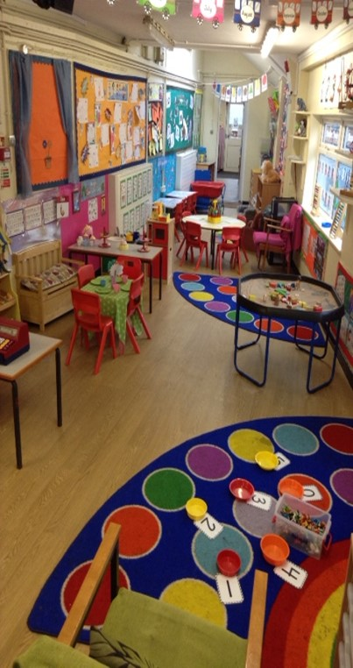

**Diary Dates: These will be updated as the term progresses**

**March:**

Monday 21st March – wellbeing workshop – class RR

Tuesday 22nd March – Stoke keep smiling project

Tuesday 22nd March –KS2 SATs information evening for parents at 6pm

Thursday 24th March – Sport for all tournament KS2

Week beginning28th March – KS2 Hassell’s Got Talent class auditions

Week beginning 4th April – KS2 Hassell’s Got Talent finals.

Friday 8th April – Last Day of term

Monday 25th April – Children return to school.

If you have any questions or things you would like to discuss with staff, please feel free to talk to myself or the staff on duty in the mornings or give the office a ring and leave your child’s class teacher a message and they will get back to you as soon as possible. We are also available via the office email on [office@hassell.staffs.sch.uk](mailto:office@hassell.staffs.sch.uk)

Kind Regards

Kirsty Broome

Head Teacher