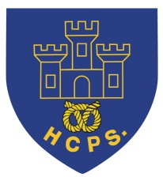 **Hassell Primary Weekly Update 17.9.2021**

Dear Parents and Carers,

It has been a very busy week and our children have been enjoying getting involved in their class topics and lessons. Our class timetables and routines are in place, but if you have any queries, please do not hesitate to get in touch with your child’s class teacher.

**Google classroom**

Please look out for your child’s new google classroom code which I will be sending via email. (Miss Ryan’s class already have theirs). Please have a go at logging in to the classroom as this will be the way we communicate and educate if we have to teach remotely. I will attach the instructions alongside the newsletter or they are also available on the school website on the remote learning tab: hassellschool.org It is also the way we will use to book parents evening appointment this term.

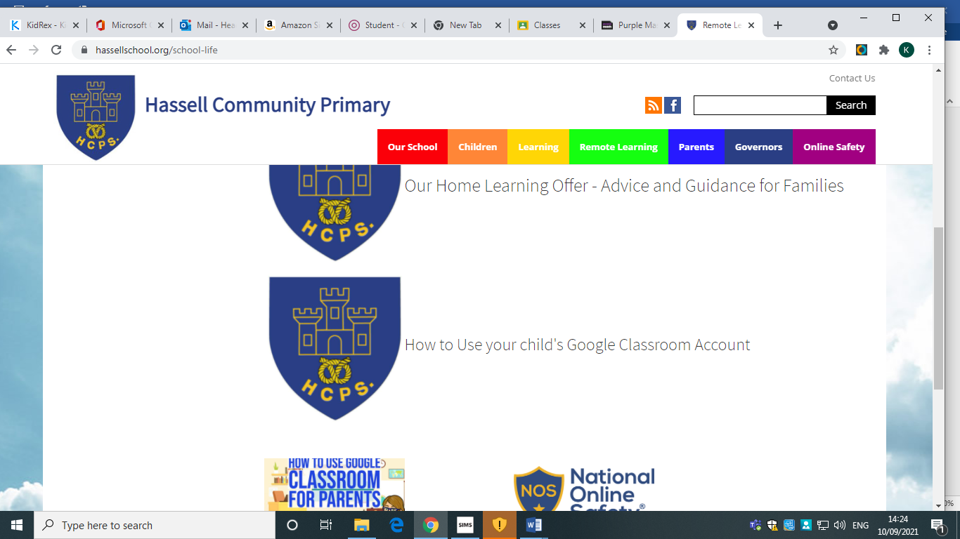

**Parents Evening:**

This term our parents evening will be online using google meet appointments. This information is being sent in a separate email.

**Allergy Information:**

We have several children and staff with life threatening allergies within our school community. As a result of this we are nut free, so children should not bring nuts as snacks, but also ask that we avoid the children having hard boiled eggs (or egg based foods such as omelet) in sandwiches and salads for the same reasons. Please remember that some chocolate spreads (e.g Nutella) also contain hazelnuts which can make children and staff poorly.

We fully appreciate that this can be difficult if they are foods your children would normally eat, but really appreciate your help to keep everyone safe.

**Named Uniform:**

Please can all children ensure their school uniform items are names so that we can ensure the correct uniform items are returned to the appropriate children.

**School Day Times:**

Our school day starts promptly at 8.50 and all children need to be in their class by this time. Registration and lessons all start straight away and late entry means that children and staff are disrupted. Please support us by ensuring that your child is in school each day on time. **From Monday 20th September the school gate will be closing promptly at 8.50 and any children arriving after this time will be recorded as late arrivals.**

Where children are ill or absent from school, please contact the school office each morning on 01782 694567 to let us know.

**McMillan Cake Sale**

****We will be having a cake sale after school on Thursday 23rd September. We would really appreciate your support with cake donations for the sale. All items will be sold at 50 pence each. Please can donations (homemade or bought) be sent into school between Monday and Thursday next week. All proceeds from the sale will go to Macmillan Cancer support.

**Diary Dates:**

W/C 20th September – European Languages Day introduction

23rd September – McMillan Cake sale – details above. Please send donations.

W/C 27th September – Parents evenings – please check for email with details on how to book your slot.

27th September – Harvest Festival Donations into school for the Foodbank and Alice Charity

8th October – World Mental Health Day – Own clothes day, details to follow

21st October – Halloween Disco

22nd October – Show Racism the red card – own clothes day, details to follow

Half Term – Monday 25th – Friday 29th October

MONDAY 1st November - INSET DAY - SCHOOL CLOSED TO PUPILS

Tuesday 2nd November – All pupils return to school.

If you have any questions or things you would like to discuss with staff, please feel free to talk to myself or the staff on duty in the mornings or give the office a ring and leave your child’s class teacher a message and they will get back to you as soon as possible. We are also available via the office email on [office@hassell.staffs.sch.uk](mailto:office@hassell.staffs.sch.uk)

Kind Regards

Kirsty Broome

Head Teacher