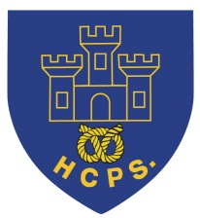 **Hassell Primary Weekly Update 15.10.2021**

Dear Parents and Carers,

**Covid Update**

As you are aware, we have had some positive cases reported this week. Today, this number has increased with further confirmed cases in Year 1and possible cases in Year 4 and 5/6. We have therefore been in communication with the Local Authority as to any additional steps we need to take.

During the week of the 18th October we will be returning completely to year group bubbles. This doesn’t make a great deal of difference to classes, except that the year 3/4 and 5/6 children will once again have different playtimes and lunchtimes and no assembly together in the hall.

All of the existing measures such as additional cleaning, hand sanitiser availability etc will continue.

On the playground before and after school, please can children from different year groups, who are not family members, stay apart so that we minimise the contact between groups at school. We know that this is not ideal but would really appreciate your support in the run up to half term.

Please can children also **STAY OFF** the playground equipment before and after school.

The Local Authority were very pleased by the lack of cases we have had in school up to this point which demonstrates that our measures are working. Thank you for everyone’s help in this as we want to work together to keep our community safe.

Unfortunately, due to staff absences, there may be some disruption to classes over the next week, but we will do our very best to keep this to a minimum. As you can imagine, things are changing on a daily basis but we will do our best to keep everyone updated.

**Black History Month**



This week’s assemblies have been based around Black History Month, learning about famous characters such as Rosa Parks, Mary Seacole and Martin Luther King, as well as more unusual characters from history such as Queen Hatshepsut. The children have made me proud showing their understanding of equality and diversity and the way they wish to treat one another equally. This also leads us into Friday’s activities on the last day of term for ‘show racism the red card’ day.

**Show Racism the Red Card**

 Friday 22nd October is a themed day in school to raise awareness about racism. The theme is ‘show racism the red card’ and is linked to the campaign to eliminate racism, particularly in sporting settings. The children may come into school dressed in their own clothes, ideally with a red coloured theme. There is no charge for this activity.



**Halloween Disco**

Sadly we have had to cancel the Halloween disco but we will still be having class parties instead. (see separate email) The children may come to school in their costumes or own clothes on Thursday 21st October. If anyone wishes to send in decorations for their children’s class they will be gratefully received.



**Welcome Back!**

It has been lovely to welcome Miss Dale back to school this week following on from her daughter’s heart surgery recovery. Miss Dale is getting to know her class and will be completing her parent’s evening after half term. Details will be sent separately to Miss Dale’s class.

**Morrisons ‘It’s Good to Grow’ Vouchers**

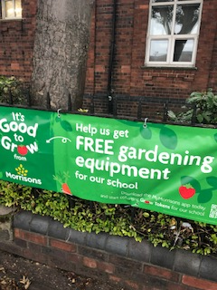 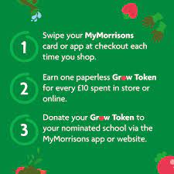

This year we have signed up for the Morrisons It’s Good to Grow voucher scheme. By collecting vouchers we can get free gardening equipment for our children to use in school. If you shop at Morrisons, one voucher can be collected for every £10 spent. Please take a minute to scan your card or APP at the checkout and collect the vouchers for us and then donate to Hassell Primary. Thank you!!

**Diary Dates:**

Until October 24th – collect Morrisons ‘It’s Good to Grow ‘ vouchers

Monday 18th October – Mrs Plummer’s virtual parent’s evening. Details in class email.

21st October – Halloween Class parties - own clothes day / Halloween costumes.

22nd October – Show Racism the red card – own clothes day, details above

Half Term – Monday 25th – Friday 29th October

**MONDAY 1st November - INSET DAY - SCHOOL CLOSED TO PUPILS**

Tuesday 2nd November – All pupils return to school.

If you have any questions or things you would like to discuss with staff, please feel free to talk to myself or the staff on duty in the mornings or give the office a ring and leave your child’s class teacher a message and they will get back to you as soon as possible. We are also available via the office email on [office@hassell.staffs.sch.uk](mailto:office@hassell.staffs.sch.uk)

Kind Regards

Kirsty Broome

Head Teacher