 **Hassell Primary Weekly Update 13.5.2022**

Dear Parents and Carers,

**SATS, phonics and times tables checks**

Well done to Year 6! The children have been amazing this week and handled their SATs test very well and we are extremely proud of them. Results will be available in July for year 6 children.

Over the next 2 weeks, the children in Year 2 will also be completing their KS1 SATs papers with Mrs Brown. These will be completed in small groups and kept as friendly as possible so that the children do not get upset or worried about their work.

In June we have the phonics screening checks for Year 1 based around the work that the children have been doing n their phonics lessons. Please keep practising your child’s phonics homework with them to support their reading.

Year 4 children also have their times tables checks. These will be completed online and work exactly the same way as the sound check on TT Rockstars. Please can all Year 4 children keep practising at home on the sound check to ensure they are confident to take their timed test on their multiplication tables. The check covers all times tables up to 12x12.

Reading – it would also help all our children to support their reading fluency with daily reading practise. All children should be reading every day as part of their homework and recording this in their diaries.

**Wear it Green Day**

Thank you to everyone who supported ‘Wear it Green Day’ for mental health awareness. This year’s theme has been about loneliness and the children have been fantastic in their support of one another to make sure we are all ok. On our playground we have the use of Buddy Stops where children can go if they need a friend or someone to talk to. Our student council members monitor these but all of the children know what they are for and how to help their friends.

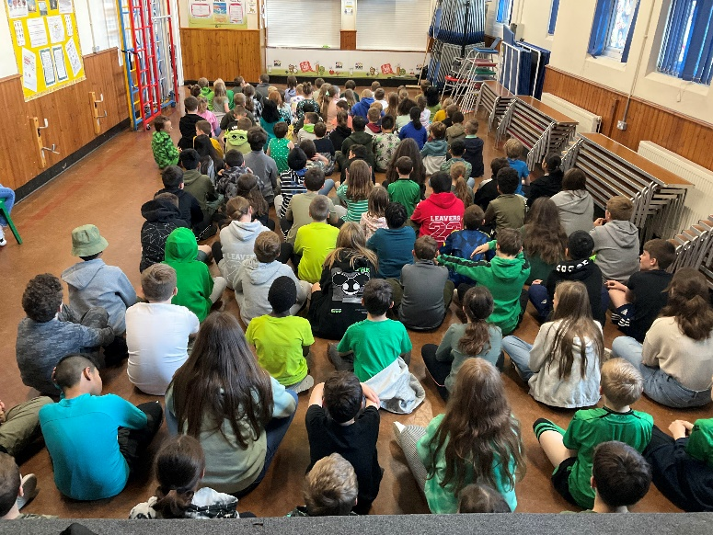

**Inset Day**

During the summer holidays we are having a considerable amount of work completed to the current Reception and Y1 classrooms. In order to support the LA with this project, the last INSET day for school will now be on Wednesday 20th July. This means that the children will finish on Tuesday 19th July. School and care club will be closed to pupils on Wednesday 20th July. Care club will reopen on Thursday 21st July.

**Time for Sport**

Thank you to everyone who has accessed the time for sport after school club for Reception (aged 5), Y1 and Y2. There are still a few spaces left for anyone wishing to take part. Please let the school office know if your child would like to join in.

**End of the day**

At the end of each day, please can we ask that parents stand back a little from the areas where the children come out, particularly by the KS1 white door and on the KS2 playground. This just makes it a little easier for staff to see the children out to parents safely. Thank you.

**Funky Shoes Day**

On Tuesday 17th May we are having a Funky Shoes Day to encourage the children to walk to school or park and stride. This is to help reduce pollution and encourage fitness. The children can wear their favourite shoes and funky socks to school for the day.

 

**Jubilee Celebrations**

During the week of the 23rd – 27th May we will be having different activities as part of the Jubilee Celebrations.

On Thursday 26th in the afternoon we will be having an afternoon tea party. The theme is royalty, dress to impress or red, white and blue and the children can come to school dressed as Kings, Queens, princesses etc, in their favourite outfit or in the colours of red, white and blue. The PTFA have kindly funded food and drink for the afternoon and we hope to join together as a whole school for the picnic.

We also have various activities across the week such as a ‘design a crown’ competition, portrait drawing and fun and games linked to the jubilee. Julie from Kraft Kidz has started our whole school art project with the children and is making a plaque made from individual crowns to commemorate the platinum jubilee.

The ‘Friends of the Guildhall’ will be marking the occasion with a crowning ceremony on Saturday 4th June. Children who wish to take part as page boys or maids of honour have been asked to submit a short piece of writing about what they think would be the most important qualities for a king or queen. The best ones will be chosen to take part. If your child would like to enter their ideas, please send their written ideas to me at [headteacher@hassell.staffs.sch.uk](mailto:headteacher@hassell.staffs.sch.uk) as soon as possible so that we can forward them onto the friends. Alternatively, children can enter directly by contacting the friends at:

The Guildhall, High Street Newcastle, Staffs, ST5 2JD Tel: 01782 632895 07983 983840 e: fotguildhall@gmail.com

In addition – on the Thursday and Friday there will be craft activities: hat making for the Sunday Jubilee parade, making Jubilee pom poms and other things and also quizzes.

On Saturday there will be a music workshop in the morning and story-telling in the afternoon following the crowning ceremony. On the Sunday there will be a street party on the Stones with children and adult choirs, dancing, a magic show and face painting.

**Care Club**

As you may be aware, our care club runs before school, after school and during the holidays. We currently have spaces before and after half term. If you would like to have a place, please contact Miss Barlow at [happytimesltd@outlook.com](mailto:happytimesltd@outlook.com) or contact school for further details.

**Nursery Places**

Our Nursery currently has a small number of places left for the Autumn Term. Places are available to children in the term after they turn 3 years old for 15 hours or 30 hours, depending on parent’s entitlements. If you would like to further information, please see the EYFS pages on our school website. Please contact the school office if you would like to book a place for this September.

**Diary Dates: These will be updated as the term progresses**

**May:**

Week beginning Monday 16th – KS1 SATS (to be completed over 2 weeks)

Tuesday 17th - Nursery and Reception information evening for September 2022 5.30pm

Tuesday 17th – funky shoes day

Thursday 19th – Y5 drama workshop

Friday 20th – KS2 Dog safety workshops with the dogs trust

Week beginning 23rd May – Jubilee Week

Mon 23rd May – Year 3 and 4 trip to the Wolsely centre

Tuesday 24th – Academy photographers taking class / group photos

Wednesday 25th – Young Voices concert in Manchester

Thursday 26th – Whole school picnic

Friday 27th – KS2 Sports at NULS 9.30 start

Monday 30th May – Friday 3rd June – HALF TERM

**June:**

Monday 6th June – INSET day. School closed to pupils

Tuesday 7th June – School open to pupils

Week Beginning Tuesday 7th – Phonics screening week

Wednesday 6th – 24th – Year 4 multiplication check to be completed during this period

Thursday 9th  - Year 5 drama workshop

Thursday 9th – Y3/4 chance to shine cricket

**July**

Wednesday 6th – EYFS sports morning at school. 9.15 start

Thursday 7th – KS1 Sports morning at NULS 9.30 start

Thursday 14th – Y6 Leaver’s Assembly 6.30 start

Friday 15th – Y6 leaver’s disco 6.30 – 8pm

If you have any questions or things you would like to discuss with staff, please feel free to talk to myself or the staff on duty in the mornings or give the office a ring and leave your child’s class teacher a message and they will get back to you as soon as possible. We are also available via the office email on [office@hassell.staffs.sch.uk](mailto:office@hassell.staffs.sch.uk)

Kind Regards

Kirsty Broome

Head Teacher