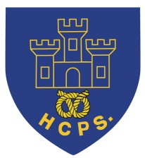 **Hassell Primary Weekly Update 3.9.2021**

Dear Parents and Carers,

It has been a very busy week and our children have been fantastic in getting used to their new timetables and starting their new topics. All families should have received their class topic letters which give information for this term. If you haven’t had this information via email or paper copy, please let your child’s class teacher know.

**Google classroom**

Please look out for your child’s new google classroom code which I will be sending via text. (Miss Ryan’s class already have theirs). Please have a go at logging in to the classroom as this will be the way we communicate and educate if we have to teach remotely. I will attach the instructions alongside the newsletter or they are also available on the school website on the remote learning tab: hassellschool.org

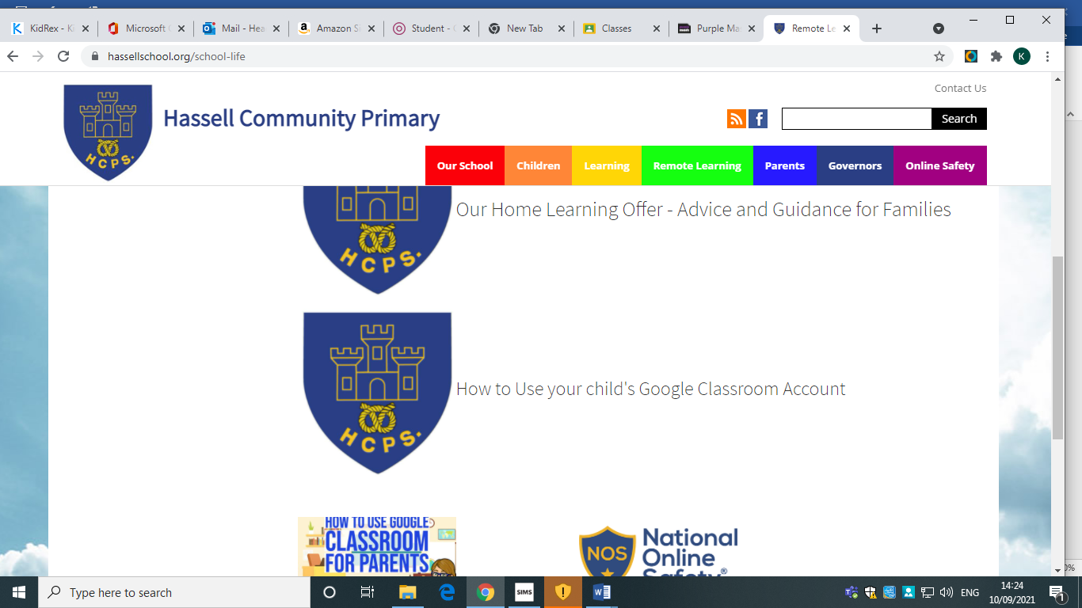

**Allergy Information:**

We have several children and staff with life threatening allergies within our school community. As a result of this we are nut free, so children should not bring nuts as snacks, but also ask that we avoid the children having hard boiled eggs (or egg based foods such as omelet) in sandwiches and salads for the same reasons. Please remember that some chocolate spreads (e.g Nutella) also contain hazelnuts which can make children and staff poorly.

We fully appreciate that this can be difficult if they are foods your children would normally eat, but really appreciate your help to keep everyone safe.

**Named Uniform:**

Please can all children ensure their school uniform items are names so

**School Day Times:**

Our school day starts promptly at 8.50 and all children need to be in their class by this time. Registration and lessons all start straight away and late entry means that children and staff are disrupted. Please support us by ensuring that your child is in school each day on time. **From Monday 13th September the school gate will be closing promptly at 8.50 and any children arriving after this time will be recorded as late arrivals.**

Where children are ill or absent from school, please contact the school office each morning on 01782 694567 to let us know.

**Toast and break time snacks.**

Children in KS2 may order toast for break time at a cost of 20p per slice. Maximum of 2 slices per child. Please send toast money in to your child’s class teacher for this to be ordered, ideally on a Monday for the rest of the week. Alternatively, KS2 children may bring in their own healthy snack such as fruit or cereal bars. Sweets, crisps and chocolate etc are not allowed at morning break. Children in Nursery, Reception and KS1 are provided with a daily fruit snack at break time each morning.

**Diary Dates:**

W/C 13th September – LMA sports clubs commence

15th September – International day of democracy

W/C 20th September – European Languages Day introduction

23/24th September – McMillan Cake sale – details to follow

W/C 27th September – Parents evenings – details to follow

27th September – Harvest Festival Donations into school for the Foodbank and Alice Charity

8th October – World Mental Health Day – Own clothes day, details to follow

21st October – Halloween Disco

22nd October – Show Racism the red card – own clothes day, details to follow

Half Term – Monday 25th – Friday 29th October

MONDAY 1st November - INSET DAY - SCHOOL CLOSED TO PUPILS

Tuesday 2nd November – All pupils return to school.

If you have any questions or things you would like to discuss with staff, please feel free to talk to myself or the staff on duty in the mornings or give the office a ring leave your child’s class teacher a message and they will get back to you as soon as possible. We are also available via the office email on [office@hassell.staffs.sch.uk](mailto:office@hassell.staffs.sch.uk)

Kind Regards

Kirsty Broome

Head Teacher