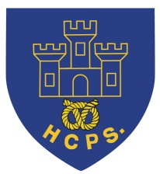 **Hassell Primary Weekly Update 1.10.2021**

Dear Parents and Carers,

**Harvest Update**

Thank you to everyone who donated to our Harvest collection. The children have enjoyed learning about the reasons behind Harvest celebrations and how our donations will help people within our local community. Your generosity is fantastic and we could not have done so much without your support. The donations will be distributed between the Alice Charity and local food bank to go to local families. Please can any final donations be brought in on Monday so staff can take the donations to the 2 centres. Thank you.

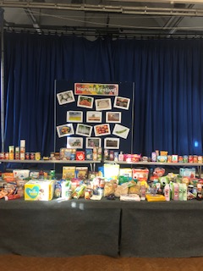

**World Mental Health Day**

On Friday 8th October we will be supporting World Mental Health Day with an own clothes day. The children can come into school wearing yellow or something comfy, for the donation of £1. The money raised will be shared between Younger Minds and school to purchase mental health books.

**Dangerous Driving and Car Parking**

The local Police have been in contact regarding concerns about dangerous parking and driving in the area surrounding our school. They have witnessed drivers travelling the wrong way down a one way street, parking on double yellow lines and blocking the car park on Hassell Street. Whilst we appreciate that there are other local schools within the area around Hassell, we also want our children and families to remain safe. Please park sensibly and respect the parking rules and regulations so that we do all we can to prevent any accidents. Thank you.

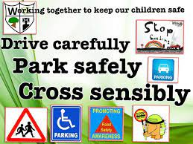

**Reading:**

As we all know reading is a vital life skill that all of our children need. We would really appreciate your support to listen to the children read on a daily basis. All children can earn reading awards for reading regularly at home and we encourage them to practice daily, which ever year group they are in. We look forward to giving out lots of reading awards across school.

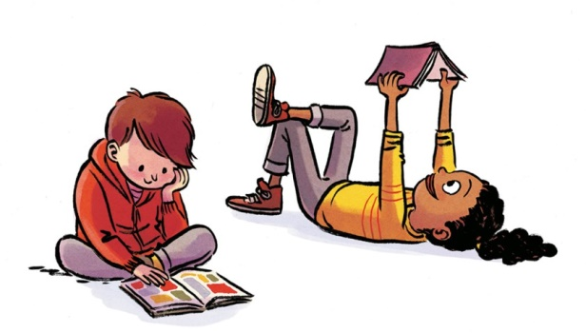

**Free School Meals**

**If your child is eligible for free school meals we may also be able to access additional funding to support with trips, activities and clubs.**

Your child may be able to get free school meals if you get any of the following:

* Income Support
* income-based Jobseeker’s Allowance
* income-related Employment and Support Allowance
* support under Part VI of the Immigration and Asylum Act 1999
* the guaranteed element of Pension Credit
* Child Tax Credit (provided you’re not also entitled to Working Tax Credit and have an annual gross income of no more than £16,190)
* Working Tax Credit run-on - paid for 4 weeks after you stop qualifying for Working Tax Credit
* Universal Credit - if you apply on or after 1 April 2018 your household income must be less than £7,400 a year (after tax and not including any benefits you get)

Children who get paid these benefits directly, instead of through a parent or guardian, can also get free school meals.

If your child is eligible for free school meals, they’ll remain eligible until they finish the phase of schooling (primary or secondary) they’re in on 31 March 2022.

**Please use the following link to apply:**

<https://www.staffordshire.gov.uk/Education/Educational-awards-benefits/FreeSchoolMeals/Apply-online.aspx>

**Lunch time menu choices**

For those children having school dinners, please can the Microsoft forms choices be completed each week. This helps us to know how many of each meal to prepare. The link is sent out each week to be completed by Monday morning. Please help your child make their choices for the week and complete the form to let us know. Thank you

**Goodbye and Good Luck!**

Today we said goodbye to Mrs Emery-Hyson who leaves us to start a Masters Degree at university. We wish her every success in her new qualification and career. Good Luck Mrs Hyson!

**Macmillan Cancer Support.**

Thank you to everyone who supported our cake sale last week. We raised a **fantastic £237** for the cancer support charity.



**Diary Dates:**

8th October – World Mental Health Day – Own clothes day, details above

21st October – Halloween Disco

22nd October – Show Racism the red card – own clothes day, details to follow

Half Term – Monday 25th – Friday 29th October

MONDAY 1st November - INSET DAY - SCHOOL CLOSED TO PUPILS

Tuesday 2nd November – All pupils return to school.

If you have any questions or things you would like to discuss with staff, please feel free to talk to myself or the staff on duty in the mornings or give the office a ring and leave your child’s class teacher a message and they will get back to you as soon as possible. We are also available via the office email on [office@hassell.staffs.sch.uk](mailto:office@hassell.staffs.sch.uk)

Kind Regards

Kirsty Broome

Head Teacher