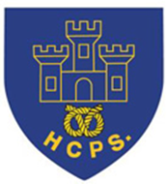
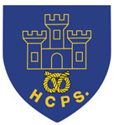
February’s Author Profile – TOM FLETCHER.

This month we will be finding out more about the author Tom Fletcher.

About the Author
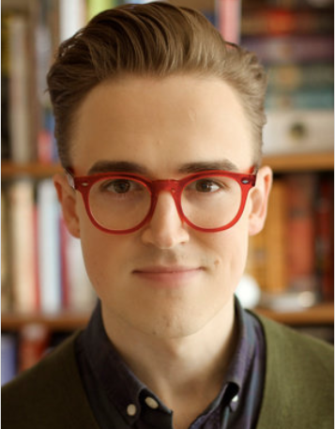

Famous for being a member of the band McFly, Tom Fletcher has gone on to become a bestselling children's author. Tom was born on July 17, 1985 in Harrow, London, England as Thomas Michael Fletcher. He has been married to Giovanna Fletcher since May 12, 2012. They have three children, Buzz, Buddy and Max. Tom is a Star Wars fan and he has 3 cats. Marvin a ginger Tom cat, and two girls, Leia and Aurora who are both black and white. Leia is named after Princess Leia from the Star Wars films, while Aurora is named after the Disney princess.
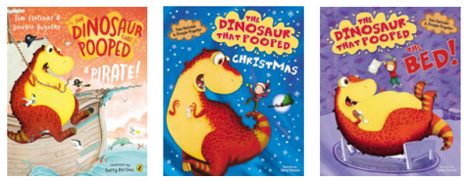
Tom’s first published writing was the Dinosaur Who Pooped... series written with fellow bandmate, Dougie Poynter.

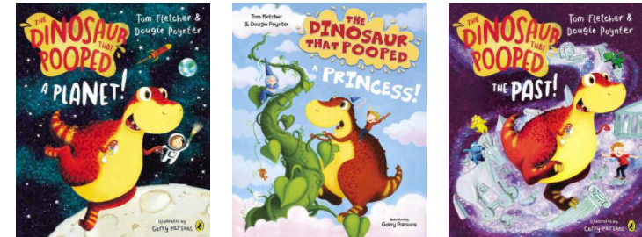

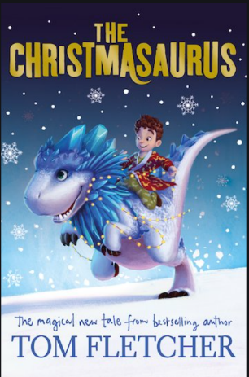
In 2016, Tom Fletcher released his first solo book The Christmasaurus which immediately caught the imaginations of children across the country – lots of the children here at Hassell included!! 'The Christmasaurus' is a story about a boy named William Trundle, and a dinosaur, the Christmasaurus. It's about how they meet one Christmas Eve and have a magical adventure. It's about friendship and families, sleigh bells and Santa, singing elves and flying reindeer, music and magic. Tom followed this book with a second book about the same characters called The Christmasaurus and the Winter Witch.
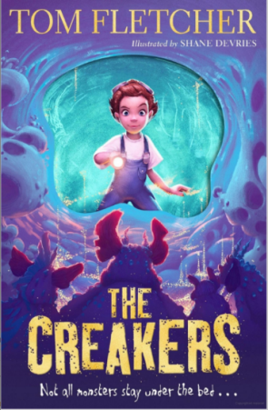
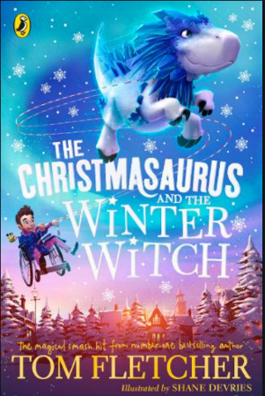

In 5/6G, we are currently reading The Creakers in our Reading for Pleasure sessions, and so far we are loving it! In the book, the children of Whiffington wake up one morning to discover that all the grown-ups have disappeared, stolen away in the night by – what? Amidst the chaos of unmade beds, unbrushed teeth and unwashed dishes, Lucy Dungston is determined to rescue her mum, even when she realises that the revolting Creakers are the kidnappers. There isn’t a child in the land who hasn’t imagined something lurking under the bed, and the idea of the bumbling, muttering, smelly Creakers will give them a delicious thrill.
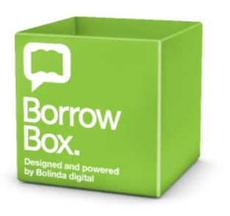
If you are interested in other books by Tom Fletcher, click the following link to see what else he has written. There is a synopsis (a brief overview) of each book so you can see which stories appeal to you. www.lovereading4kids.co.uk/author/4548/Tom-Fletcher.html
You can borrow eBooks from Newcastle Library using their BorrowBox App – you just need your Library ID and PIN number. (On your library card). Don’t worry if you’re not already a member, you can join online here:
www.yourlibcat.staffordshire.gov.uk/web/arena/self-registration
You can search for books by a keyword, by the title, by the author or by the narrator:
fe.bolindadigital.com/wldcs_bol_fo/b2i/search.html?b2bSite=6431&searchBy=ALL&q=tom+fletcher
If you decide to read one of Tom’s books, let me know if you enjoyed it and why.

Mrs Goodstadt.

